CryptoStreamX:
Real-time Crypto Trade Analytics Pipeline








Name: Nuwan Keshara Galappaththi
LinkedIn: https://www.linkedin.com/in/nuwan-keshara/
Contents
1) Project 3
2) Objectives / Problem Statement 3
3) Tech Stack 4
4) Architecture / System Design 5
Workflow Steps: 5
5) Implementation Steps 6
1. Data Ingestion (Python) 6
2. Data Quality Checks (Python) 6
3. Transformation and Modeling (ksqlDB) 6
4. Storage (ClickHouse) 8
5. Code and Results 9
6) Summary 13

Project

- CryptoStreamX: Real-time Crypto Trade Analytics Pipeline
CryptoStreamX is a fully streaming data pipeline that captures and processes live cryptocurrency trade data from Binance in real time. Built with Apache Kafka, the system ingests, buffers and distributes high-throughput event streams. Kafka Streams and ksqlDB power in-flight transformations, aggregations and real-time analytics without external compute layers. Kafka Connect integrates with ClickHouse, a high-performance columnar database, for ultra-fast storage and query execution on time-series trade data. This architecture delivers a scalable, fault-tolerant data flow from ingestion to analytics, enabling instant insights into trading activity, price movements and market patterns.

Objectives / Problem Statement

- Live cryptocurrency trade data is highly volatile and comes as a continuous stream. Analyzing this data using traditional batch processes introduces latency, limiting real-time insights into trading activity and price fluctuations..

- Data Stream (Websocket) - wss://stream.binance.com:9443/stream?streams=btcusdt@trade

- Goal:
Build a fully streaming data pipeline that:
- Ingests live trade data from Binance in real time.
- Ensures data quality and schema consistency via Avro schemas and Kafka.
- Applies in-flight transformations and aggregations with ksqlDB.
- Stores processed trade data in ClickHouse for high-performance analytics.
- Enables near-real-time reporting.

Tech Stack

  Layer
  Tool
  Purpose
 | Binance WebSocket API
  Data Source
  Live cryptocurrency trades (BTC, ETH, etc.)
 | Apache Kafka
  Messaging & Streaming
  High-throughput message broker for real-time ingestion and buffering
Cluster Management | Apache Zookeeper | Manage Cluster brokers
 | Confluent Schema Registry
  Schema Management
  Enforces Avro schemas for data consistency
Streaming Processing | ksqlDB / Kafka Streams
  In-flight data transformations, aggregations and windowed analytics
Storage / Analytics | ClickHouse
  Columnar DB optimized for time-series and high-performance queries
  Programming
  Python (WebSockets, Confluent Kafka)
  Data ingestion, transformations
Version Control |  | Code management
  Git / GitHub
Environment Management | Python dotenv | Secure configuration management

Architecture / System Design

- Pipeline Flow
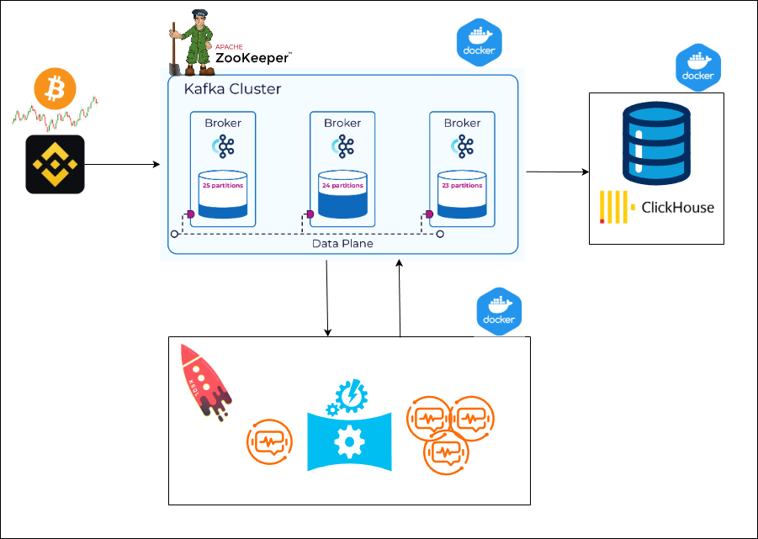

Workflow Steps:
- Live ingestion from Binance WebSocket into Kafka topics.
- Schema validation using Confluent Schema Registry to ensure Avro schema compliance.
- In-flight transformations and aggregations in ksqlDB:
- Windowed aggregations (1-minute and 5- minute tumbling windows, 10-second grace periods)
- Real-time calculation of metrics like trade count, total quantity, average price, min/max prices.
- High-performance storage in ClickHouse for real-time querying.

Implementation Steps

Data Ingestion (Python)
- WebSocket Client:
  - Connects to Binance WebSocket API.
  - Receives live trade messages and parses JSON payloads.
  - Transforms each trade into Avro-compliant dictionary records.
- Kafka Producer:
  - Serializes messages with AvroSerializer.
  - Publishes trade data to Kafka topic ‘binance_trade’.
  - Handles errors, retries and ensures minimal message loss.

Data Quality Checks (Python)
- Validates messages for:
  - Missing fields (e.g., event_time, symbol, trade_id)
  - Numeric validation (price ≥ 0, quantity ≥ 0)
  - Boolean field normalization (market_maker, ignore)
  - Logs issues to logs/producer.log.

Transformation and Modeling (ksqlDB)
- Stream Creation:
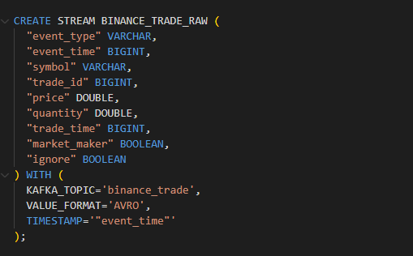

- Aggregations (1-minute tumbling windows):
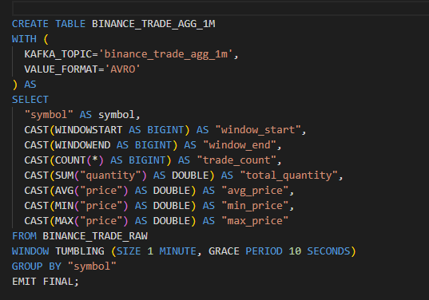

- Aggregations (5-minute tumbling windows):
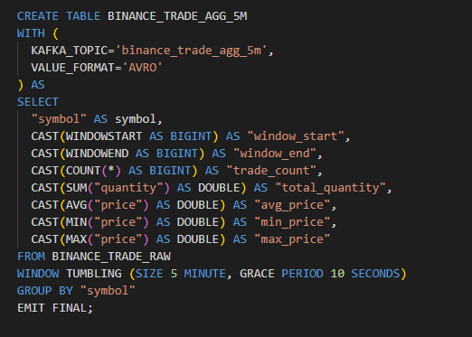

Storage (ClickHouse)
- Kafka Connect Sink streams aggregated tables into ClickHouse.
  - ClickHouse schema:
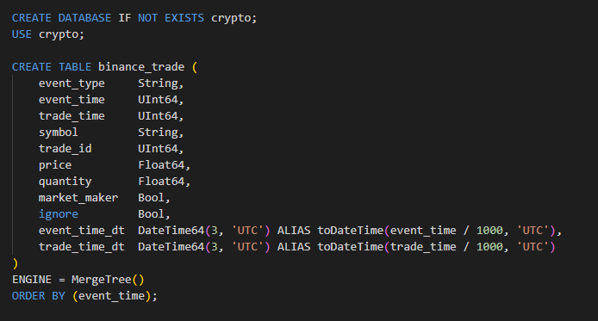

  - Aggregations (1-minute tumbling windows):
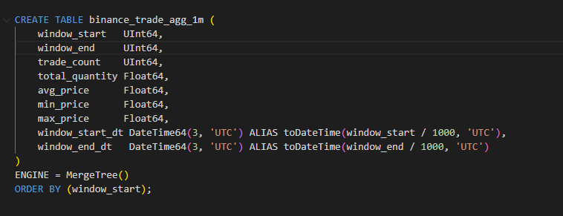

  - Aggregations (5-minute tumbling windows):
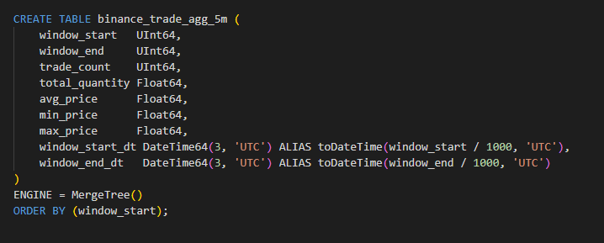

Code and Results
- Producer Example:
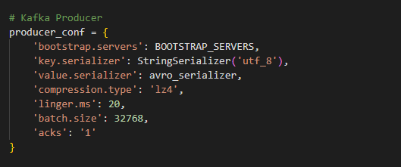
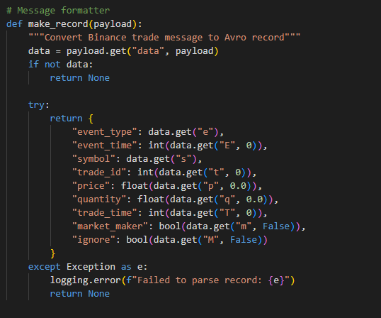

- Kafka UI:
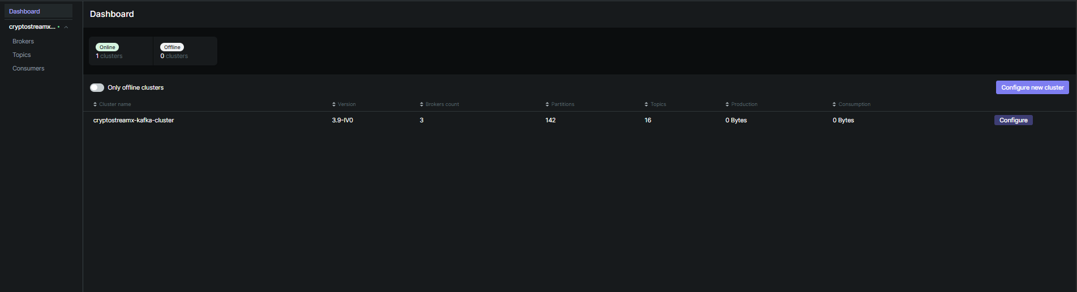
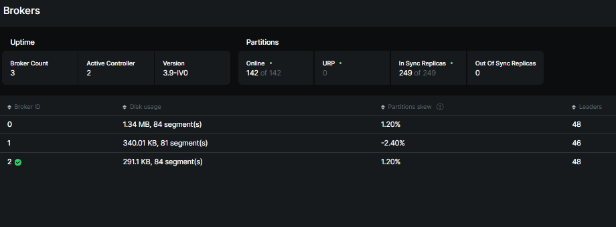

- Kafka Topics:
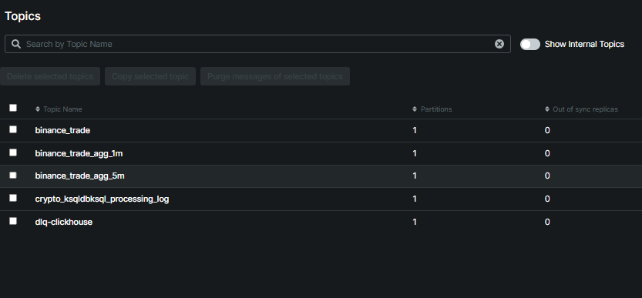

- Raw data stream- binance_trade topic
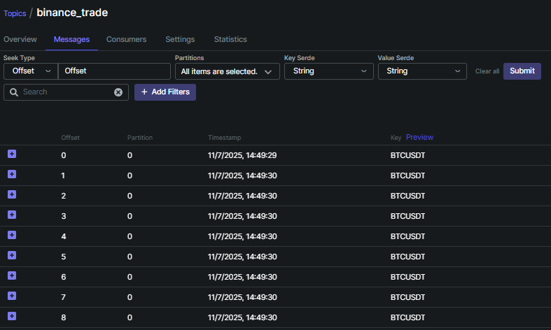

- Aggregated Data Stream 1-minute period - binance_trade_agg_1m (Avro)
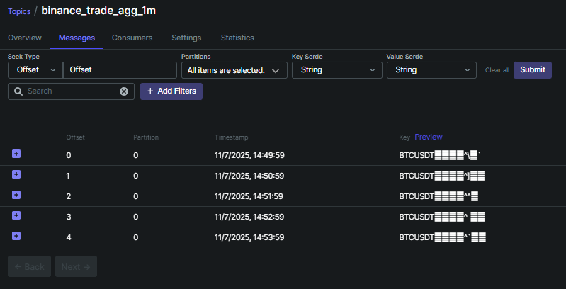

- Aggregated Data Stream 5-minute period - binance_trade_agg_5m (Avro)
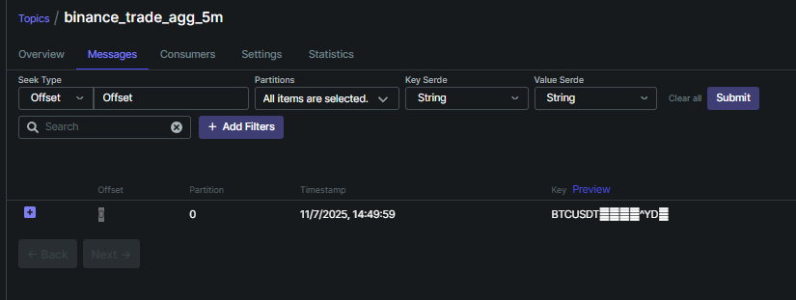

- Clickhouse Database raw data stream
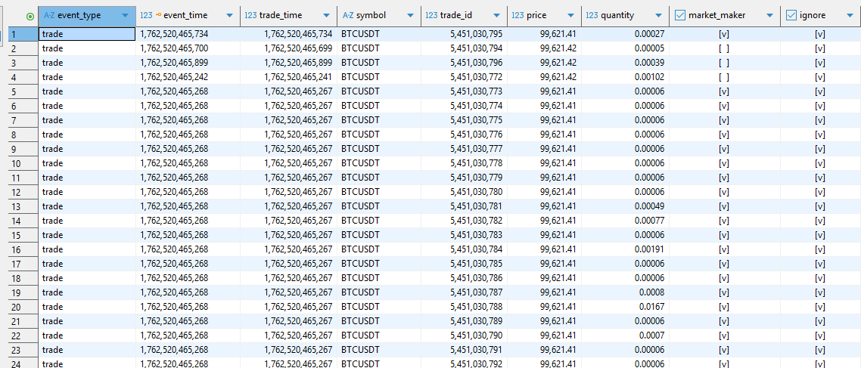

- Clickhouse aggregated data (1m and 5m)
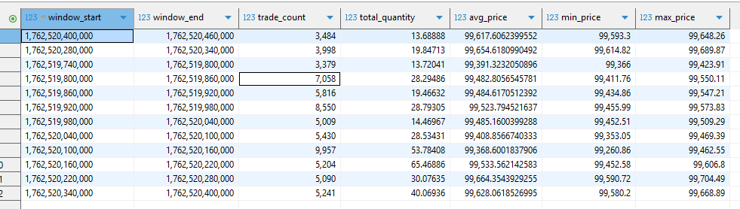

Summary

CryptoStreamX demonstrates a modern, end-to-end streaming data architecture that is scalable, fault-tolerant and built for real-time analytics. This system captures live cryptocurrency trade data, validates and transforms it in-flight and delivers analytics-ready metrics with minimal latency.

Core Components:
- Apache Kafka:
  - Handles high-throughput, real-time data ingestion and buffering between producers and consumers.
- Apache Zookeeper:
  - Manages Kafka cluster coordination, leader election and configuration synchronization across brokers, ensuring high availability and fault tolerance.
- Confluent Schema Registry:
  - Maintains Avro schemas to enforce consistent message structure and backward compatibility between producer and consumer applications.
- ksqlDB:
  - Performs continuous, in-flight transformations and real-time aggregations directly on Kafka topics.
- ClickHouse:
  - A high-performance columnar database for storing and querying time-series trade data, enabling fast analytical queries and historical trend analysis.

Key Achievements:
- Real-time trade analytics with low latency from data ingestion to visualization.
- Fault-tolerant Kafka cluster managed by Zookeeper for reliable message delivery and partition replication.
- Schema validation via Avro, preventing ingestion of inconsistent messages.
- Fully modular architecture, easily extendable to new data sources or additional metrics.
- Instant analytical queries, supporting aggregations on trade data.

